# Project Name: FlyAway.

## GitHub Link:

<https://github.com/tamasjit/myjavaproject/tree/master/Phase%202/Phase-2_Final%20Assesment/q2_FlyAway>

## Output:

### Homepage:

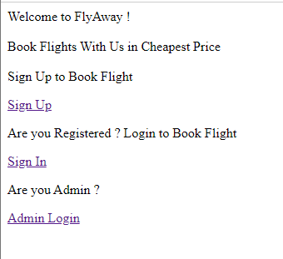

### Sign Up:

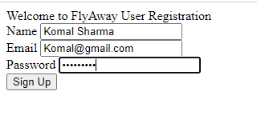

### UserLogin/Sign In:

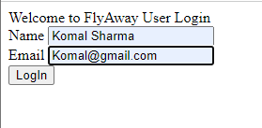

### SearchFlight:

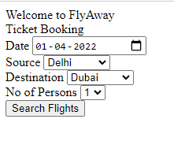

### Booking Page:

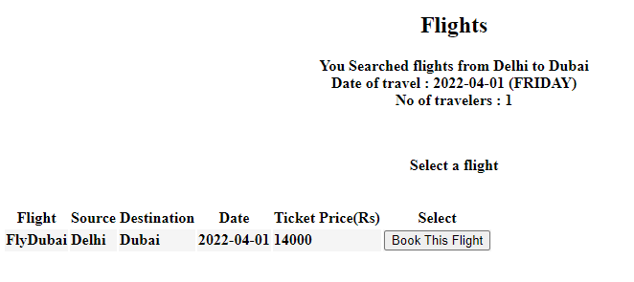

### Entering Personal Details:

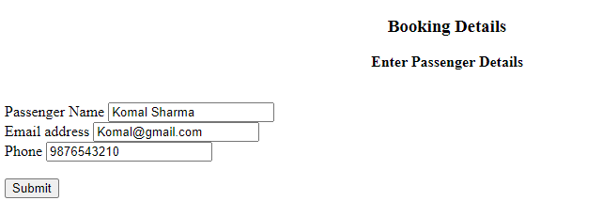

### Payment Page:

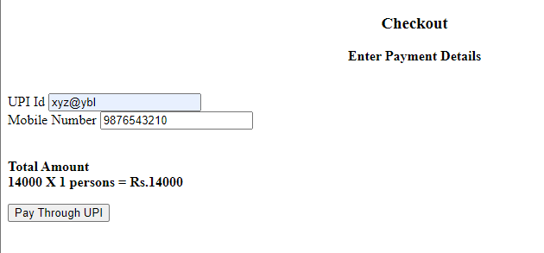

### Booking Confirm:

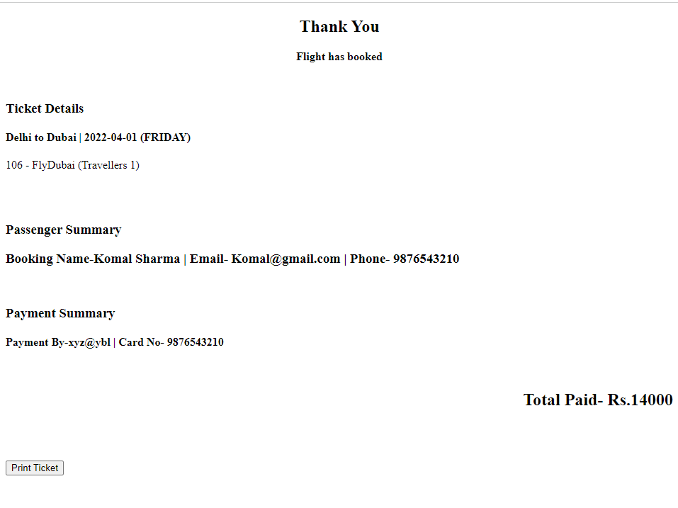

### Printing Ticket:

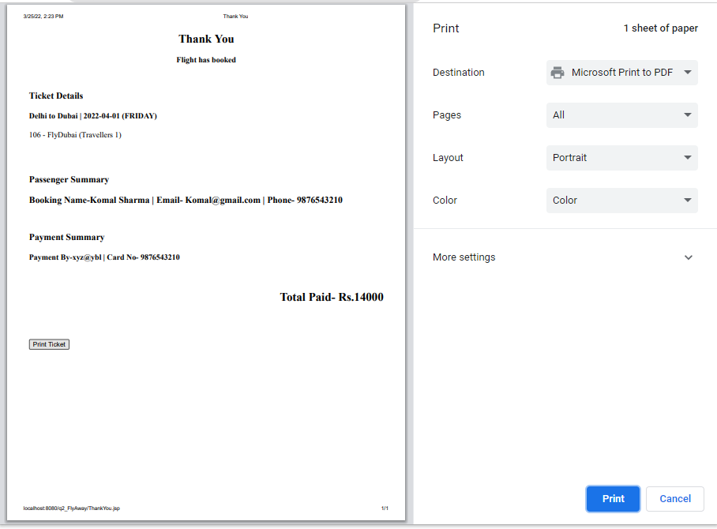

### AdminLogin:

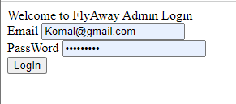

### Invalid Login:

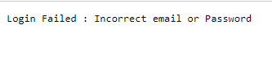

### Admin Dashboard:

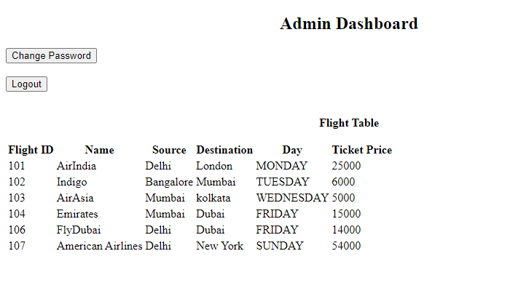

### Change Admin Password:

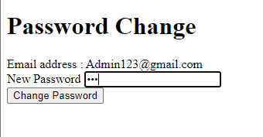



### Database Outputs:

